MyProject Solution Design

Scope:

The information being saved is the player’s high score, an integer determined by the total of several integers received from pickups that the player collides with, as well as the xyz position of the player in the form of an FVector and the positions of any objects with the custom actor component attached in the form of a TMap.

Data Format:

The data is saved in the format of a JSON text file.

Processing:

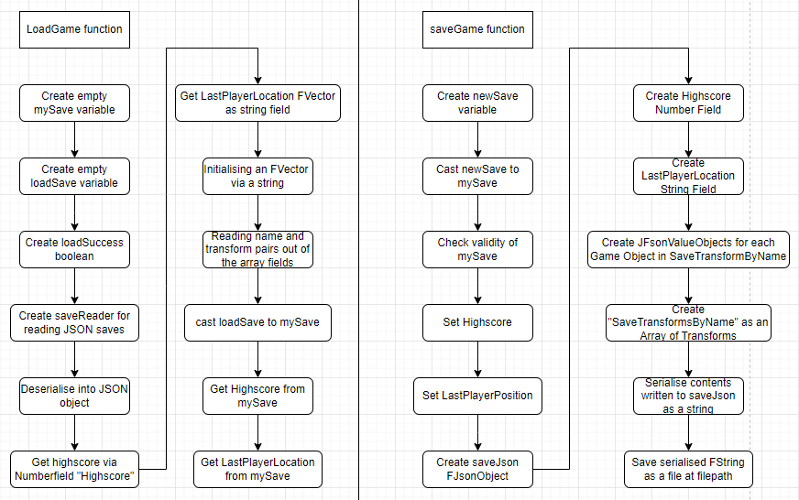

Workflow/Pipeline:

To add this to a new project, you would need to change the gamemode and character class to the ones included in the C++ solution. Any objects that need to have their position saved will need the relevant actor component added to them. Any variables (besides Highscore and Last Position) that need to be saved will need to be properly implemented into the C++ solution. Finally, it’s important to make sure that the “Use JSONSave Game” setting is on.